D ECATHLO N

ACADEMIC

James A. Garfield High School
5101 East Sixth Street, Los Angeles, California 90022
Telephone: (323) 981-5500

MARCH 18, 2012 CALIFORNIA STATE ACADEMIC DECATHLON RESULTS

THE TEAM

HONOR DIVISION SCHOLASTIC DIVISION VARSITY DIVISION
RAYMUNDO FLORES ANTHONY ALVAREZ JOHNNY HA
EMMANUEL OCAMPO RICHARD AVILA MARIO NUNEZ
ERICK OCAMPO-RAMOS STEPHANIE HARO BRYAN VILLASENOR

TEAM RESULTS: TOTAL COMPETITION: 65 HIGH SCHOOLS

OVERALL AFTER 10 EVENTS:20TH IN THE STATE 54TH IN THE COUNTRY (APPROX. OUT OF 1700 SCHOOLS)
SUPERQUIZ ORAL + WRITTEN-11TH PLACE
OVERALL TEAM SCORE AFTER 10 EVENTS-DIVISION II-SECOND PLACE-TROPHY FOR SCHOOL-SILVER MEDALS FOR ALL
SUPERQUIZ ORAL + WRITTEN TEAM SCORE-DIVISION II-SECOND PLACE-PLAQUE FOR SCHOOL-SILVER MEDALS FOR ALL

INDIVIDUAL RESULTS

RAYMUNDO FLORES
OVERALL TEAM SCORE AFTER 10 EVENTS-DIVISION II-SECOND PLACE-SILVER MEDAL
SUPERQUIZ ORAL + WRITTEN TEAM SCORE-DIVISION II-SECOND PLACE-SILVER MEDAL

EMMANUEL OCAMPO
ART-1ST PLACE-GOLD MEDAL
ECONOMICS-3RD PLACE-BRONZE MEDAL
LANGUAGE AND LITERATURE-1ST PLACE-GOLD MEDAL
MUSIC-1ST PLACE-GOLD
SUPERQUIZ (INDIVIDUAL ACHIEVEMENT)-2ND PLACE-SILVER MEDAL
HIGHEST SCORING STUDENT FOR GARFIELD HIGH-GOLD MEDAL
OVERALL TEAM SCORE AFTER 10 EVENTS-DIVISION II-SECOND PLACE-SILVER MEDAL
SUPERQUIZ ORAL + WRITTEN TEAM SCORE-DIVISION II-SECOND PLACE-SILVER MEDAL
STATE RANKING-4TH DIVISION II
STATE RANKING-36TH OVER ALL
NATIONAL RANKING-77TH OVERALL

ERICK OCAMPO-RAMOS
OVERALL TEAM SCORE AFTER 10 EVENTS-DIVISION II-SECOND PLACE-SILVER MEDAL
SUPERQUIZ ORAL + WRITTEN TEAM SCORE-DIVISION II-SECOND PLACE-SILVER MEDAL

SCHOLASTIC DIVISION:

ANTHONY ALVAREZ
OVERALL TEAM SCORE AFTER 10 EVENTS-DIVISION II-SECOND PLACE-SILVER MEDAL
SUPERQUIZ ORAL + WRITTEN TEAM SCORE-DIVISION II-SECOND PLACE-SILVER MEDAL

RICHARD AVILA
SCIENCE-3RD PLACE-BRONZE MEDAL
OVERALL TEAM SCORE AFTER 10 EVENTS-DIVISION II-SECOND PLACE-SILVER MEDAL
SUPERQUIZ ORAL + WRITTEN TEAM SCORE-DIVISION II-SECOND PLACE-SILVER MEDAL
STATE RANKING-45TH OVERALL
NATIONAL RANKING OVERALL-75TH

STEPHANIE HARO
ECONCOMICS-1ST PLACE-GOLD MEDAL
SCIENCE-2ND PLACE-SILVER MEDAL
OVERALL AFTER 10 EVENTS-THE 2ND HIGHEST RANKING SCHOLASTIC STUDENT IN THE STATE-SILVER MEDAL
OVERALL TEAM SCORE AFTER 10 EVENTS-DIVISION II-SECOND PLACE-SILVER MEDAL
SUPERQUIZ ORAL + WRITTEN TEAM SCORE-DIVISION II-SECOND PLACE-SILVER MEDAL
STATE RANKING-25TH OVER ALL
STATE RANKING-54TH DIVISION II
NATIONAL RANKING-77TH OVERALL

VARSITY DIVISION:

JOHHNY HA
OVERALL TEAM SCORE AFTER 10 EVENTS-DIVISION II-SECOND PLACE-SILVER MEDAL
SUPERQUIZ ORAL + WRITTEN TEAM SCORE-DIVISION II-SECOND PLACE-SILVER MEDAL

MARIO NUNEZ
OVERALL TEAM SCORE AFTER 10 EVENTS-DIVISION II-SECOND PLACE-SILVER MEDAL
SUPERQUIZ ORAL + WRITTEN TEAM SCORE-DIVISION II-SECOND PLACE-SILVER MEDAL

BRYAN VILLASENOR
OVERALL TEAM SCORE AFTER 10 EVENTS-DIVISION II-SECOND PLACE-SILVER MEDAL
SUPERQUIZ ORAL + WRITTEN TEAM SCORE-DIVISION II-SECOND PLACE-SILVER MEDAL

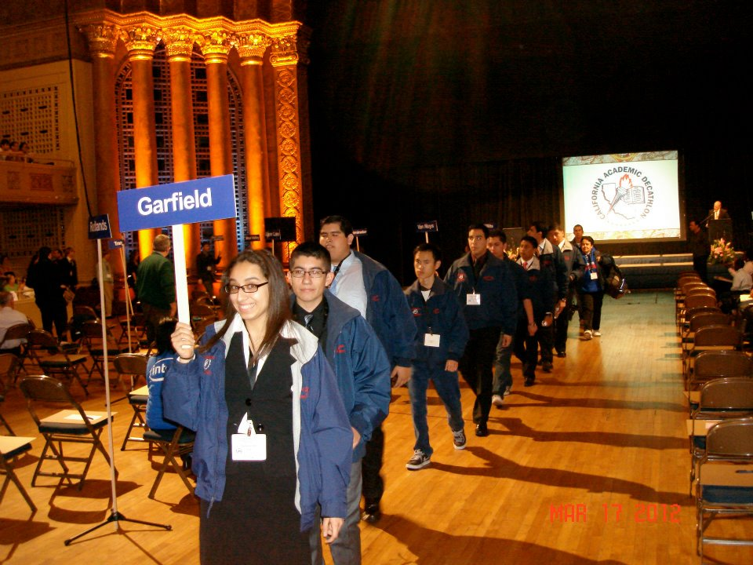

STARTING FROM THE FRONT-STEPHANIE HARO, BRYAN VILLASENOR, MARIO NUNEZ, JOHNNY HA, RICHARD AVILA, ANTHONY ALVAREZ, RAYMOND FLORES, EMMANUEL OCAMPO, ERICK OCAMPO-RAMOS, COACHES-L.B. ROMERO AND KEVIN MURHIE

